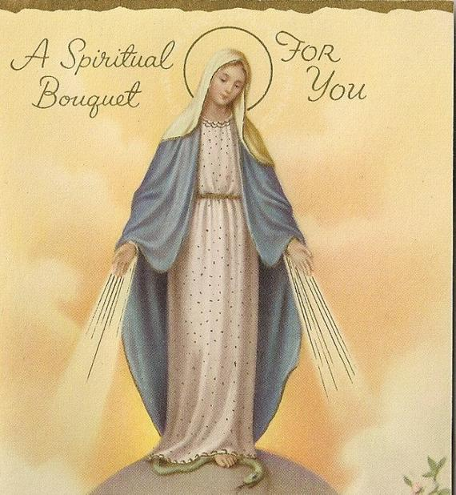
A Spiritual Bouquet for You!
I said a prayer for you today and I know God must have heard.
I felt the answer in my heart although he spoke no words.
I prayed that He'd be near you at the start of each day,
to grant you health and blessings and friends to share your way.
I asked for happiness for you in all things great and small,
but it was for his loving care I prayed for most of all.
From (Name): Eternal Father we offer You the Holy Face of Your Divine Son, Our Lord
Jesus Christ in reparation of all sins, conversion of all sinners, salvation of all souls throughout the world, and by That Holy Face, which is also Your Face dear Father, we Ask You, through the intercession of our great Mediatrix, the Mother of Our Lord and Our Mother, through the intercession of all the Saints and Angels in Heaven, and by the power of the Holy Spirit, to irradiate the Christ Light into every cell and atom of (your name)! Where there is the Christ Light there can be no darkness! Jesus we Trust in You! Father, also shower (your name) and all his family and friends with the peace and consolation that only You can impart!

By His Holy Face and in His Name we ask, we give thanks, we Bless You, we Adore you, O most Holy Trinity!
ABBA FATHER, THY WILL BE DONE! AMEN.

Come Holy Spirit, come by the means of the Power of the Flame of Love of the Immaculate Heart of Mary!

Jesus, we Trust in You! We surrender to You, Take care of everything!

Mother Mary, we trust in You,
Spread the Effect of Grace of Thy Flame of Love over all involved in this case, over (your name), his family, and all of Humanity!

Pray with and for them and all of us who have recourse to You.

(Name) will pray the Rosary for you.
(Name) will offer daily Mass and a meditation for you.
(Name) will make a general intention with our Blessed Mother that you will be remembered in their family Rosary.
(Name) will fast on Wednesday for you and offer a decade of a daily Rosary for you.
(Name) will offer a Novena of three Hail Marys for you.
(Name) will offer her daily morning prayers (lauds) for you for nine days.
(Name) will offer a week of Rosaries for you.
(Name) will offer a Novena of three Hail Marys for you.
(Name) will pray three Hail Mary’s daily for nine days for you.
(Name) will offer 5 prayers to St. Michael the Archangel and 4 daily Mass intentions for you.
(Name) will offer a Rosary for you.
(Name) will offer a Rosary, Mass, Holy Communion, Divine Mercy Chaplet, and two acts of self-denial for you.
(Name) will be praying for you during their nightly prayers.
(Name) will offer a Rosary for you.
(Name) will pray the Divine Mercy Chaplet and three Golden Arrow prayers for you.
(Name) will offer a decade of the Rosary for you daily for ten days.
(Name) are praying for you.
(Name) will offer a daily Angelus for you for ten days.
(Name) will pray an Our Father, Hail Mary, and Glory Be for you.
(Name) will offer a Mass and Communion, a Rosary, and a Novena of three Hail Marys for you.
(Name) will offer a Mass and a Rosary for you.
(Name) will offer a Mass for you.
(Name) will offer a Holy Hour for you.
(Name) will offer the Holy Eucharist from six Masses for you.
(Name) will offer a Novena of Memorares for your intentions.
(Name) will offer a Rosary and an Hour of Adoration for you.
(Name) will pray the Rosary and offer a Holy Hour for you.
(Name) will pray a novena of Rosaries for you.
(Name) will offer a Rosary for you.
(Name) will offer a Rosary for you.
(Name) will offer a Holy Hour for you.
(Name) will pray the Divine Mercy Chaplet for you.
(Name) family will offer a Rosary for you daily for ten days.
(Name) will pray for your strength and wisdom.
(Name) family will offer three Hail Marys daily for ten days.
(Name) will offer a Novena of three Hail Marys for you.
(Name) family will add you to their daily family Rosary intentions and Kelly will offer a Mass for you.
(Name) will offer a Memorare for you.
(Name) will offer the Chaplet of Divine Mercy for you.
(Name) will offer an Angelus for you.
(Name) will offer ten Masses, ten Rosaries, ten visits to the Blessed Sacrament, and pray for you daily by name.
(Name) will offer three Hail Marys for you.
(Name) will offer a Holy Hour, Mass, and Prayer for Priests for you.
(Name) will offer several Masses, Rosaries, Memorares, and Divine Mercy chaplets for you.
(Name) and the (Name) student body will pray the noonday Angelus for you.
(Name) will offer 5 Angeluses, 5 Rosaries, and 5 Masses for you.
(Name) family will offer the Prayer for Priests by St. Therese of the Child Jesus daily for you for at least one month.
(Name) will offer an Our Father, a Hail Mary, and a Glory Be for you.
(Name) will offer a Rosary for you.
(Name) will pray the Litany for Priests for you.
(Name) will offer the Novena to the Sacred Heart for you.
(Name) and her three children will offer one Hail Mary daily for nine days for you.
(Name) will offer two Masses and seven Rosaries for you.
(Name) will offer the following prayers daily for you for ten days: Our Father, Hail Mary, Glory Be, St. Michael Prayer, Prayer to the Sacred Heart of Jesus for Priests, Prayer to Our Ldy of the Tears for our Priests, Prayer for Priests by St. John Vianney, and adds, “May the flames of Your mercy set priests on fire with Your inconceivable mercy, so lukewarm and unbelieving souls may be set ablaze with Your mercy through the ministry of priests.”
(Name) will offer a Mass, a Rosary, and a Divine Mercy chaplet, and Stations of the Cross chaplet for you.
The (Name) family will include you in their intentions for a decade of the Rosary.
(Name) will offer a Mass, a Rosary, and a Litany of Our Lord Jesus Christ, Priest and Victim for you.
(Name) will offer at least one Rosary for you.
(Name) family will offer seven Hail Marys and seven Glory Bes for you.
(Name) will offer a decade of the Rosary for you.
(Name) will offer a Mass for you.
(Name) family will pray the Rosary for you.
(Name) will offer a Divine Mercy Chaplet for you.
(Name) will pray the Rosary for you.
(Name) will pray the Divine Mercy chaplet for you.
(Name) will offer a Novena of Rosaries for you.
(Name) offer her eye discomfort for your spiritual, mental and physical health and three Mass for you.
(Name) will especially remember you as she prays the daily Rosary for you for ten days.
(Name) will offer 7 Masses, 7 Rosaries, and 7 Divine Mercy Chaplets for you.

